

CSA0501-DATABASE MANAGEMENT SYSTEMS

LAB EXPERIMENTS DATE: 12/07/2026

EXPERIMENT 3 – DML Commands (INSERT, SELECT)

AIM:
To create and manage the database structure for a Flight Reservation System using Data Definition Language (DDL) commands such as CREATE, ALTER, DROP, TRUNCATE, and RENAME.

PROCEDURE:
- Open MySQL and create the database for the Flight Reservation System.
- Use the CREATE command to create required tables such as Flight, Passenger, and Booking with suitable attributes and data types.
- Use the ALTER command to add, modify, or remove columns from an existing table.
- Use the RENAME command to change the name of an existing table.
- Use the TRUNCATE command to remove all records from a table while keeping its structure.
- Use the DROP command to permanently delete an unwanted table from the database.
- Use DESC table_name; or SHOW TABLES; after the operations to verify the changes.
- Execute each command and observe the output to ensure that all DDL operations are performed successfully.

PROGRAM:

1. CREATE TABLE:

CREATE TABLE student_details (

student_id INT PRIMARY KEY,

student_name VARCHAR(50),

department VARCHAR(50),

semester INT,

cgpa DECIMAL(3,2)

);

OUTPUT:

2. INSERT VALUES:
INSERT INTO student_details VALUES
(101,'Deepthi','CSE',5,8.75),
(102,'Anu','ECE',4,9.10),
(103,'Rahul','IT',3,8.50);

OUTPUT:

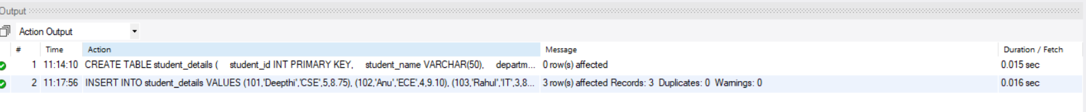
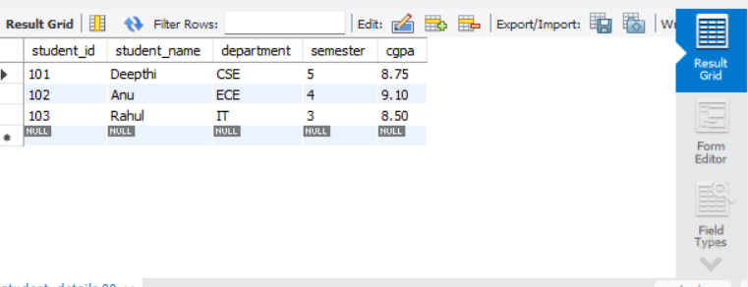

3. INSERT COMMAND:
SELECT * FROM student_details;
INSERT INTO student_cgpa_details
(student_id, student_name, department, semester, cgpa, dept_id)
VALUES
(101,'Deepthi','CSE',5,8.75,1),
(102,'Anu','ECE',4,9.10,2),
(103,'Rahul','IT',3,8.50,3);

OUTPUT:

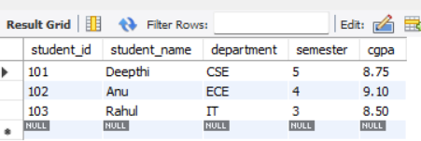
4. SELECT COMMAND:

SELECT * FROM student_cgpa_details;
OUTPUT:
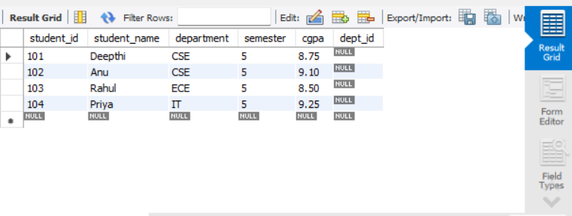

RESULT: Data Manipulation Language (DML) Commands such as INSERT, SELECT are performed

